A Project Report

on

STOCK MARKET PREDICTION

carried out as part of the Mini Project IT3101 Submitted

by

Manushi Shashank 209309022

in partial fulfilment for the award of the degree of

Bachelor of Technology

in

Data Science

Under the Guidance of
Guide Name



School of Computing and Information Technology
Department of Information Technology

MANIPAL UNIVERSITY JAIPUR
JAIPUR-303007
RAJASTHAN, INDIA

November 2022

CERTIFICATE

Date:22-11-2022

This is to certify that the minor project titled STOCK MARKET PREDICTION is a record of the bonafide work done by MANUSHI SHASHNAK (209309022) submitted in partial fulfilment of the requirements for the award of the Degree of Bachelor of Technology in Data Science of Manipal University Jaipur, during the academic year 2022-23.

Dr. Shweta Sharma

Project Guide, Department of Information Technology
Assistant Professor (Senior Scale)
Manipal University Jaipur

ABSTRACT

In Stock Market Prediction, the aim is to predict the future value of the financial stocks of a company. The recent trend in stock market prediction technologies is the use of machine learning which makes predictions based on the values of current stock market indices by training on their previous values. Machine learning itself employs different models to make prediction easier and authentic. In this project LSTM based Machine learning is used to predict stock values. Factors considered are open, close, low, high and volume.

LIST OF FIGURES

Figure No | Figure Title | Page No
1 | Pre-processing of data | 7
2 | Overall Architecture | 8
3 | Training and prediction | 9
4 | Flow of Execution | 10
5 | Dataset | 11
6 | Stock Opening Price | 11
7 | Moving Average Comparison | 12
8 | Actual Prics v/s Predicted Price | 13

1. INTRODUCTION

A correct prediction of stocks can lead to huge profits for the seller and the broker. Frequently, it is brought out that prediction is chaotic rather than random, which means it can be predicted by carefully analyzing the history of respective stock market. Machine learning is an efficient way to represent such processes. It predicts a market value close to the tangible value, thereby increasing the accuracy. Introduction of machine learning to the area of stock prediction has appealed to many researches because of its efficient and accurate measurements.

The vital part of machine learning is the dataset used. The dataset should be as concrete as possible because a little change in the data can perpetuate massive changes in the outcome. In this project, supervised machine learning is employed on a dataset obtained from Yahoo Finance. This dataset comprises of following five variables: open, close, low, high and volume. Open, close, low and high are different bid prices for the stock at separate times with nearly direct names. The volume is the number of shares that passed from one owner to another during the time period. The model is then tested on the test data.

1.1 PROBLEM STATEMENT
Time Series forecasting & modelling plays an important role in data analysis. Time series analysis is a specialized branch of statistics used extensively in fields such as Econometrics & Operation Research. Time Series is being widely used in analytics & data science. Stock prices are volatile in nature and price depends on various factors. The main aim of this project is to predict stock prices using Long short term memory (LSTM).

2. LITERATURE SURVEY

2.1 INTRODUCTION
"What other people think” has always been an important piece of information for most of us during the decision-making process. The Internet and the Web have now (among other things) made it possible to find out about the opinions and experiences of those in the vast pool of people that are neither our personal acquaintances nor well-known professional critics — that is, people we have never heard of. And conversely, more and more people are making their opinions available to strangers via the Internet. The interest that individual users show in online opinions about products and services, and the potential influence such opinions wield, is something that is driving force for this area of interest. And there are many challenges involved in this process which needs to be walked all over in order to attain proper outcomes out of them. In this survey we analysed basic methodology that usually happens in this process and measures that are to be taken to overcome the challenges being faced.

2.2 EXISTING METHODS
2.2.1 Stock Market Prediction Using Machine Learning
The research work done by V Kranthi Sai Reddy Student, ECM, Sreenidhi Institute of Science and Technology, Hyderabad, India. In the finance world stock trading is one of the most important activities. Stock market prediction is an act of trying to determine the future value of a stock other financial instrument traded on a financial exchange. This paper explains the prediction of a stock using Machine Learning. The technical and fundamental or the time series analysis is used by the most of the stockbrokers while making the stock predictions. The programming language is used to predict the stock market using machine learning is Python. In this paper we propose a Machine Learning (ML) approach that will be trained from the available stocks data and gain intelligence and then uses the acquired knowledge for an accurate prediction. In this context this study uses a machine learning technique called Support Vector Machine (SVM) to predict stock prices for the large and small capitalizations and in the three different markets, employing prices with both daily and up-to-the-minute frequencies.

2.2.4 The Stock Market and Investment
The research work done by Manh Ha Duong Boriss Siliverstovs. Investigating the relation between equity prices and aggregate investment in major European countries including France, Germany, Italy, the Netherlands and the United Kingdom. Increasing integration of European financial markets is likely to result in even stronger correlation between equity prices in different European countries. This process can also lead to convergence in economic development across European countries if developments in stock markets influence real economic components, such as investment and consumption. Indeed, our vector autoregressive models suggest that the positive correlation between changes equity prices and investment is, in general, significant. Hence, 6 monetary authorities should monitor reactions of share prices to monetary policy and their effects on the business cycle.

3. METHODOLOGY

3.1 PROPOSED SYSTEMS
The prediction methods can be roughly divided into two categories, statistical methods and artificial intelligence methods. Statistical methods include logistic regression model, ARCH model, etc. Artificial intelligence methods include multi-layer perceptron, convolutional neural network, naive Bayes network, back propagation network, single-layer LSTM, support vector machine, recurrent neural network, etc. They used Long short-term memory network (LSTM).

Long short-term memory network:
Long short-term memory network (LSTM) is a particular form of recurrent neural network (RNN).

Working of LSTM:
LSTM is a special network structure with three “gate” structures. Three gates are placed in an LSTM unit, called input gate, forgetting gate and output gate. While information enters the LSTM’s network, it can be selected by rules. Only the information conforms to the algorithm will be left, and the information that does not conform will be forgotten through the forgetting gate.

The experimental data in this paper are the actual historical data downloaded from the Internet. Three data sets were used in the experiments. It is needed to find an optimization algorithm that requires less resources and has faster convergence speed.

- Used Long Short-term Memory (LSTM) with embedded layer and the LSTM neural network with automatic encoder.
- LSTM is used instead of RNN to avoid exploding and vanishing gradients.
- In this project python is used to train the model, MATLAB is used to reduce dimensions of the input. MySQL is used as a dataset to store and retrieve data.
- The historical stock data table contains the information of opening price, the highest price, lowest price, closing price, transaction date, volume and so on.
- The accuracy of this LSTM model used in this project is 57%.

3.1.1) SYSTEM ARCHITECTURE

      - Preprocessing of data

Fig. 1 Pre-processing of data

2)Overall Architecture

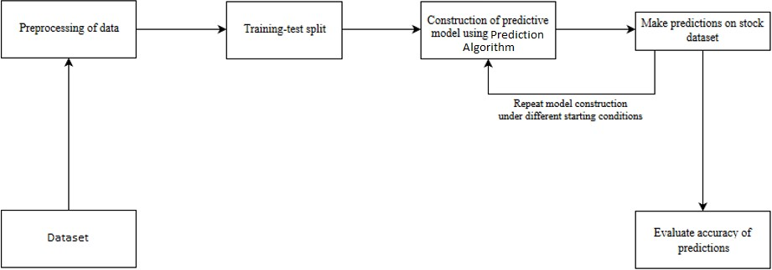

Fig. 2: Overall Architecture

4. DESIGN

4.1) Structure Chart
A structure chart (SC) in software engineering and organizational theory is a chart which shows the breakdown of a system to its lowest manageable levels. They are used in structured programming to arrange program modules into a tree. Each module is represented by a box, which contains the module's name.
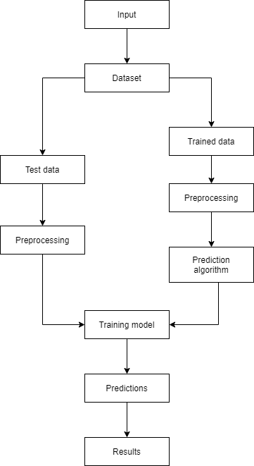

Fig. 3: Training and prediction

4..2) Flow Chart

A flowchart is a type of diagram that represents a workflow or process. A flowchart can also be defined as a diagrammatic representation of an algorithm, a step-by-step approach to solving a task. The flowchart shows the steps as boxes of various kinds, and their order by connecting the boxes with arrows.

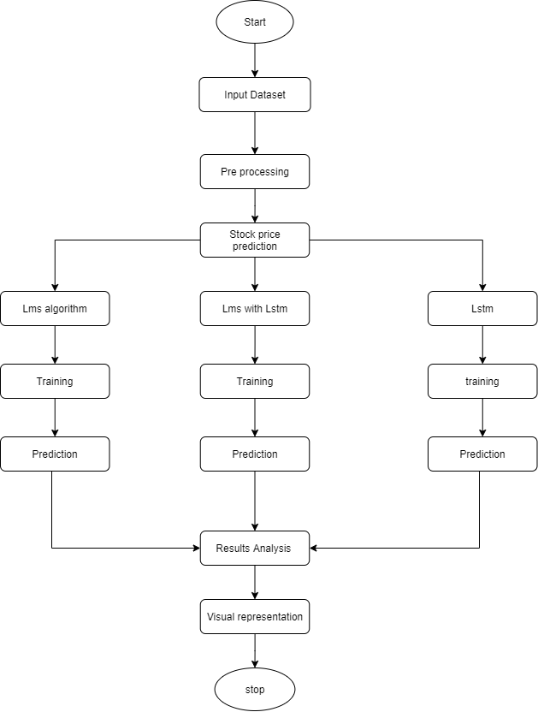

Fig. 4: Flow of execution

5.IMPLEMENTATION

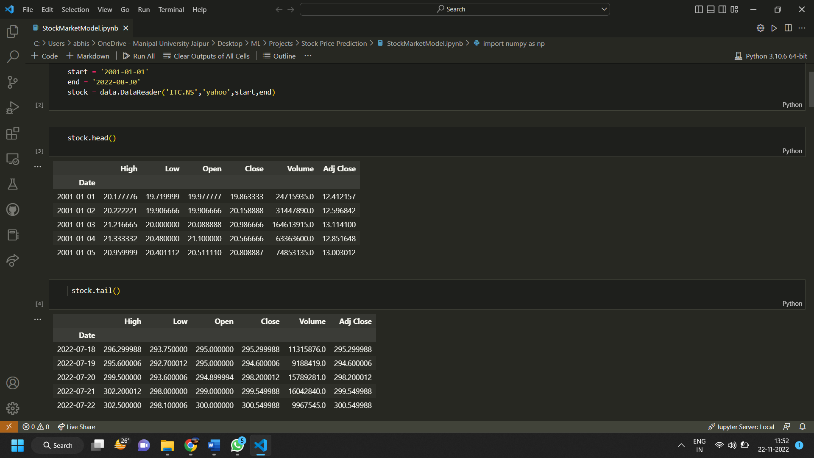
Fig. 5: Dataset

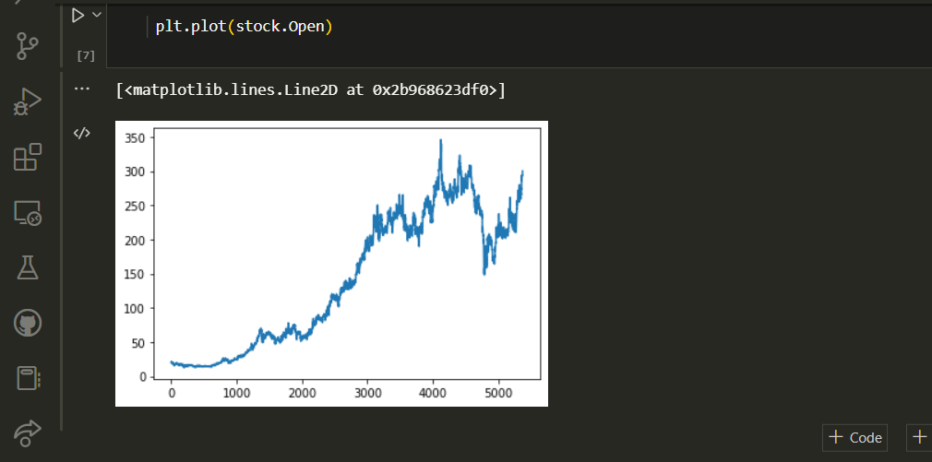
Fig. 6: Stock Opening Price

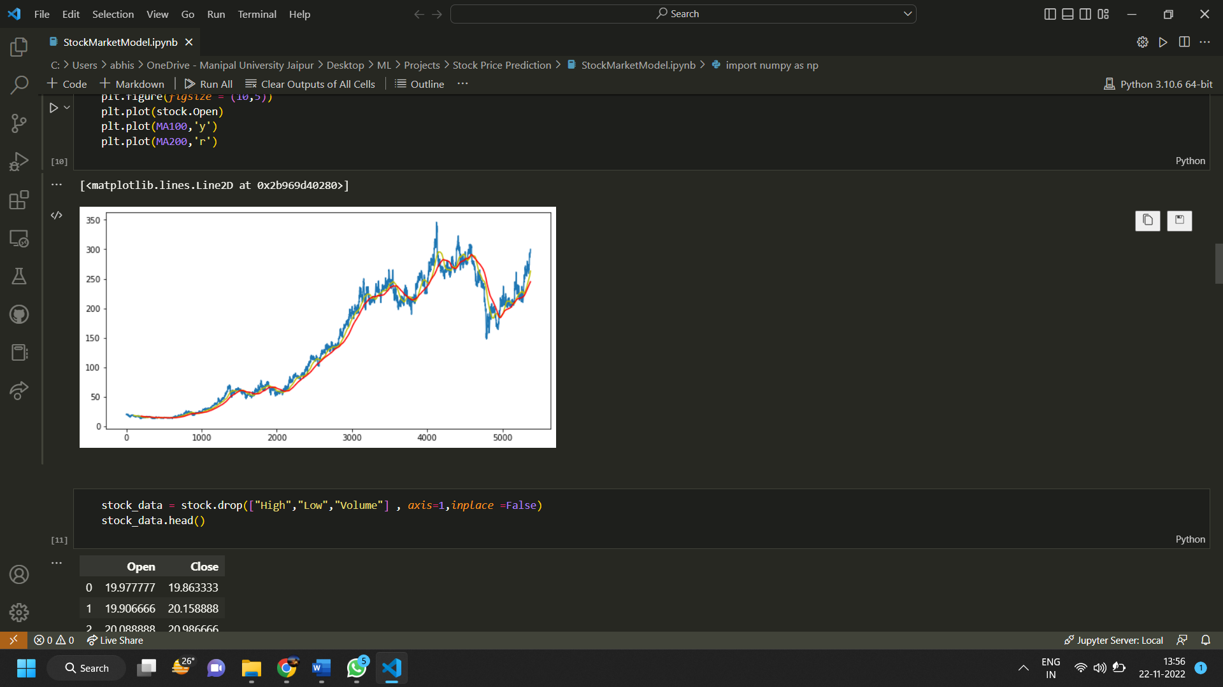

Fig. 7: Moving Average Comparison

6.RESULTS

Here is graph showing difference between Actual Price and Predicted Price when the model was trained for 50 epochs and data was taken for 10 years.
It showed around 60 percent accuracy and the predicted price was quite near the actual price.

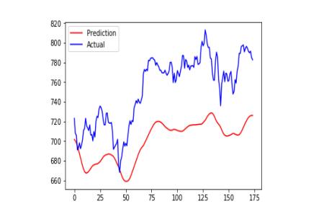

Fig. 8: Actual Prics v/s Predicted Price

7.CONCLUSION AND FUTURE WORK

7.1) Conclusion
In this project, we are predicting closing stock price of any given organization, we developed a web application for predicting close stock price using LMS and LSTM algorithms for prediction. We have applied datasets belonging to ITC, Tesla, Apple and achieved above 75% accuracy for these datasets.

7.2) Future work
I would like to add sentiment analysis to this project for better analysis.

REFERENCES (Guideline)

Journal / Conference Papers

1.M. Usmani, S. H. Adil, K. Raza and S. S. A. Ali, "Stock market prediction using machine learning techniques," 2016 3rd International Conference on Computer and Information Sciences (ICCOINS), Kuala Lumpur, 2016, pp. 322-327.

2. K. Raza, "Prediction of Stock Market performance by using machine learning techniques," 2017 International Conference on Innovations in Electrical Engineering and Computational Technologies (ICIEECT), Karachi, 2017, pp. 1-1.

3 H. Gunduz, Z. Cataltepe and Y. Yaslan, "Stock market direction prediction using deep neural networks," 2017 25th Signal Processing and Communications Applications Conference (SIU), Antalya, 2017, pp. 1-4.

